*Identify the choice that best completes or answers the question. It is highly recommended that you show work on this test.*

_____ 1. Which of the following shows the polynomial expression 

rewritten in descending order?

a. 

b. 

c. 

d. 

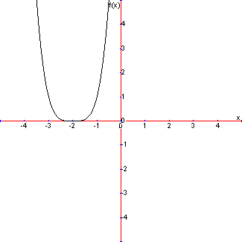

_____ 2. Which best describes the function shown in the graph?

1. even function
2. odd function
3. even and odd
4. neither even nor odd

_____ 3. If a function is odd and contains the point (4, 10), what other point must the function

contain?

a. (–4, 10)

b. (4, –10)

c. (–4, –10)

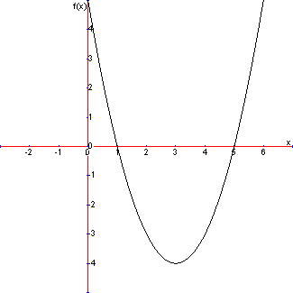 d. (–4, 0)

_____ 4. What is the range of the polynomial function 

1. all real numbers
2. *x* ≥ 3
3. *y* ≥ 3
4. *y* ≥ –4

_____ 5. What is the *y*-intercept of the function 

a. *y =* 72

b. *y =* 6

c. *y* = –18

d. *y =* –72

_____ 6. Which best describes the function 

1. even function
2. odd function
3. even and odd
4. neither even nor odd

_____ 7. Which is the graph of the function ?



a. b.

 c. d.

_____ 8. Compare the graph of  to the graph of . How

do the sign differences affect the graph?

1. reflects graph through *y*-axis
2. reflects graph through *x*-axis
3. dilates graph by a factor of 2
4. translates graph down 2 units

_____ 9. What type of symmetry does the graph of  have?

1. symmetric with respect to the *x*-axis only
2. symmetric with respect to the *y*-axis only
3. symmetric with respect to the origin only
4. symmetric with respect to the *x­*-axis, *y*-axis, and origin

_____ 10. What are the zeros of the quadratic function 

1. –2 and 3
2. –3 and 2
3. –6 and 1
4. –1 and 6

_____ 11. Which of the following describes the zeros of the polynomial function

 and their multiplicities?

1. 3 is a zero with a multiplicity of two and –4 is a zero with a multiplicity of three.
2. –3 is a zero with a multiplicity of two and 4 is a zero with a multiplicity of three.
3. 0 is a zero with a multiplicity of one, –3 is a zero with a multiplicity of two and 4 is a zero with a multiplicity of three.
4. 0 is a zero with a multiplicity of one, 3 is a zero with a multiplicity of two and –4 is a zero with a multiplicity of three.

_____ 12. Which of the following statements describes an odd function?

a. 

b. 

c. 

d. 

_____ 13. The graph of a certain polynomial function has the following characteristics:

* The graph goes downward on both the left and the right
* The graph has a relative minimum and two relative maxima.
* The graph has a range of *y* ≤ 5.

Which of the following could be the degree of the function?

1. degree 2
2. degree 3
3. degree 4
4. degree 5

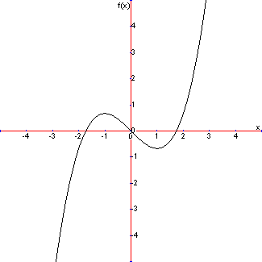_____ 14. The function  has a relative minimum at what position?

1. *x* = –1
2. *y* = 0
3. *x* = 1
4. *y* = 1

_____ 15. Which best describes the end behavior of the graph of the polynomial function



1. The graph increases to ∞ on the left and decreases to –∞ on the right.
2. The graph decreases to –∞ on both the left and the right.
3. The graph increases to ∞ on both the left and the right.
4. The graph decreases to –∞ on the left and increases to ∞ on the right.

_____ 16. Which is the graph of the function ?



a. b.



c. d.

_____ 17. Which of the following describes the zeros of the polynomial function



1. –3 (multiplicity 2); 3 (multiplicity 2)
2. –9 (multiplicity 2); 9 (multiplicity 2)
3. 3 (multiplicity 4)
4. –3 (multiplicity 4)

_____ 18. For which polynomial function does its graph have an absolute maximum?

a. 

b. 

c. 

d. 

_____ 19. Which best describes the end behavior of the graph of the polynomial function



1. The graph increases without limit on the left and decreases without limit on the right.
2. The graph decreases without limit on both the left and the right.
3. The graph increases without limit on both the left and the right.
4. The graph decreases without limit on the left and increases without limit on the right.

_____ 20. Match the graph shown below to the appropriate polynomial function.



a. 

b. 

c. 

d. 