Independent & Dependent Variables
Positive & Negative Correlation
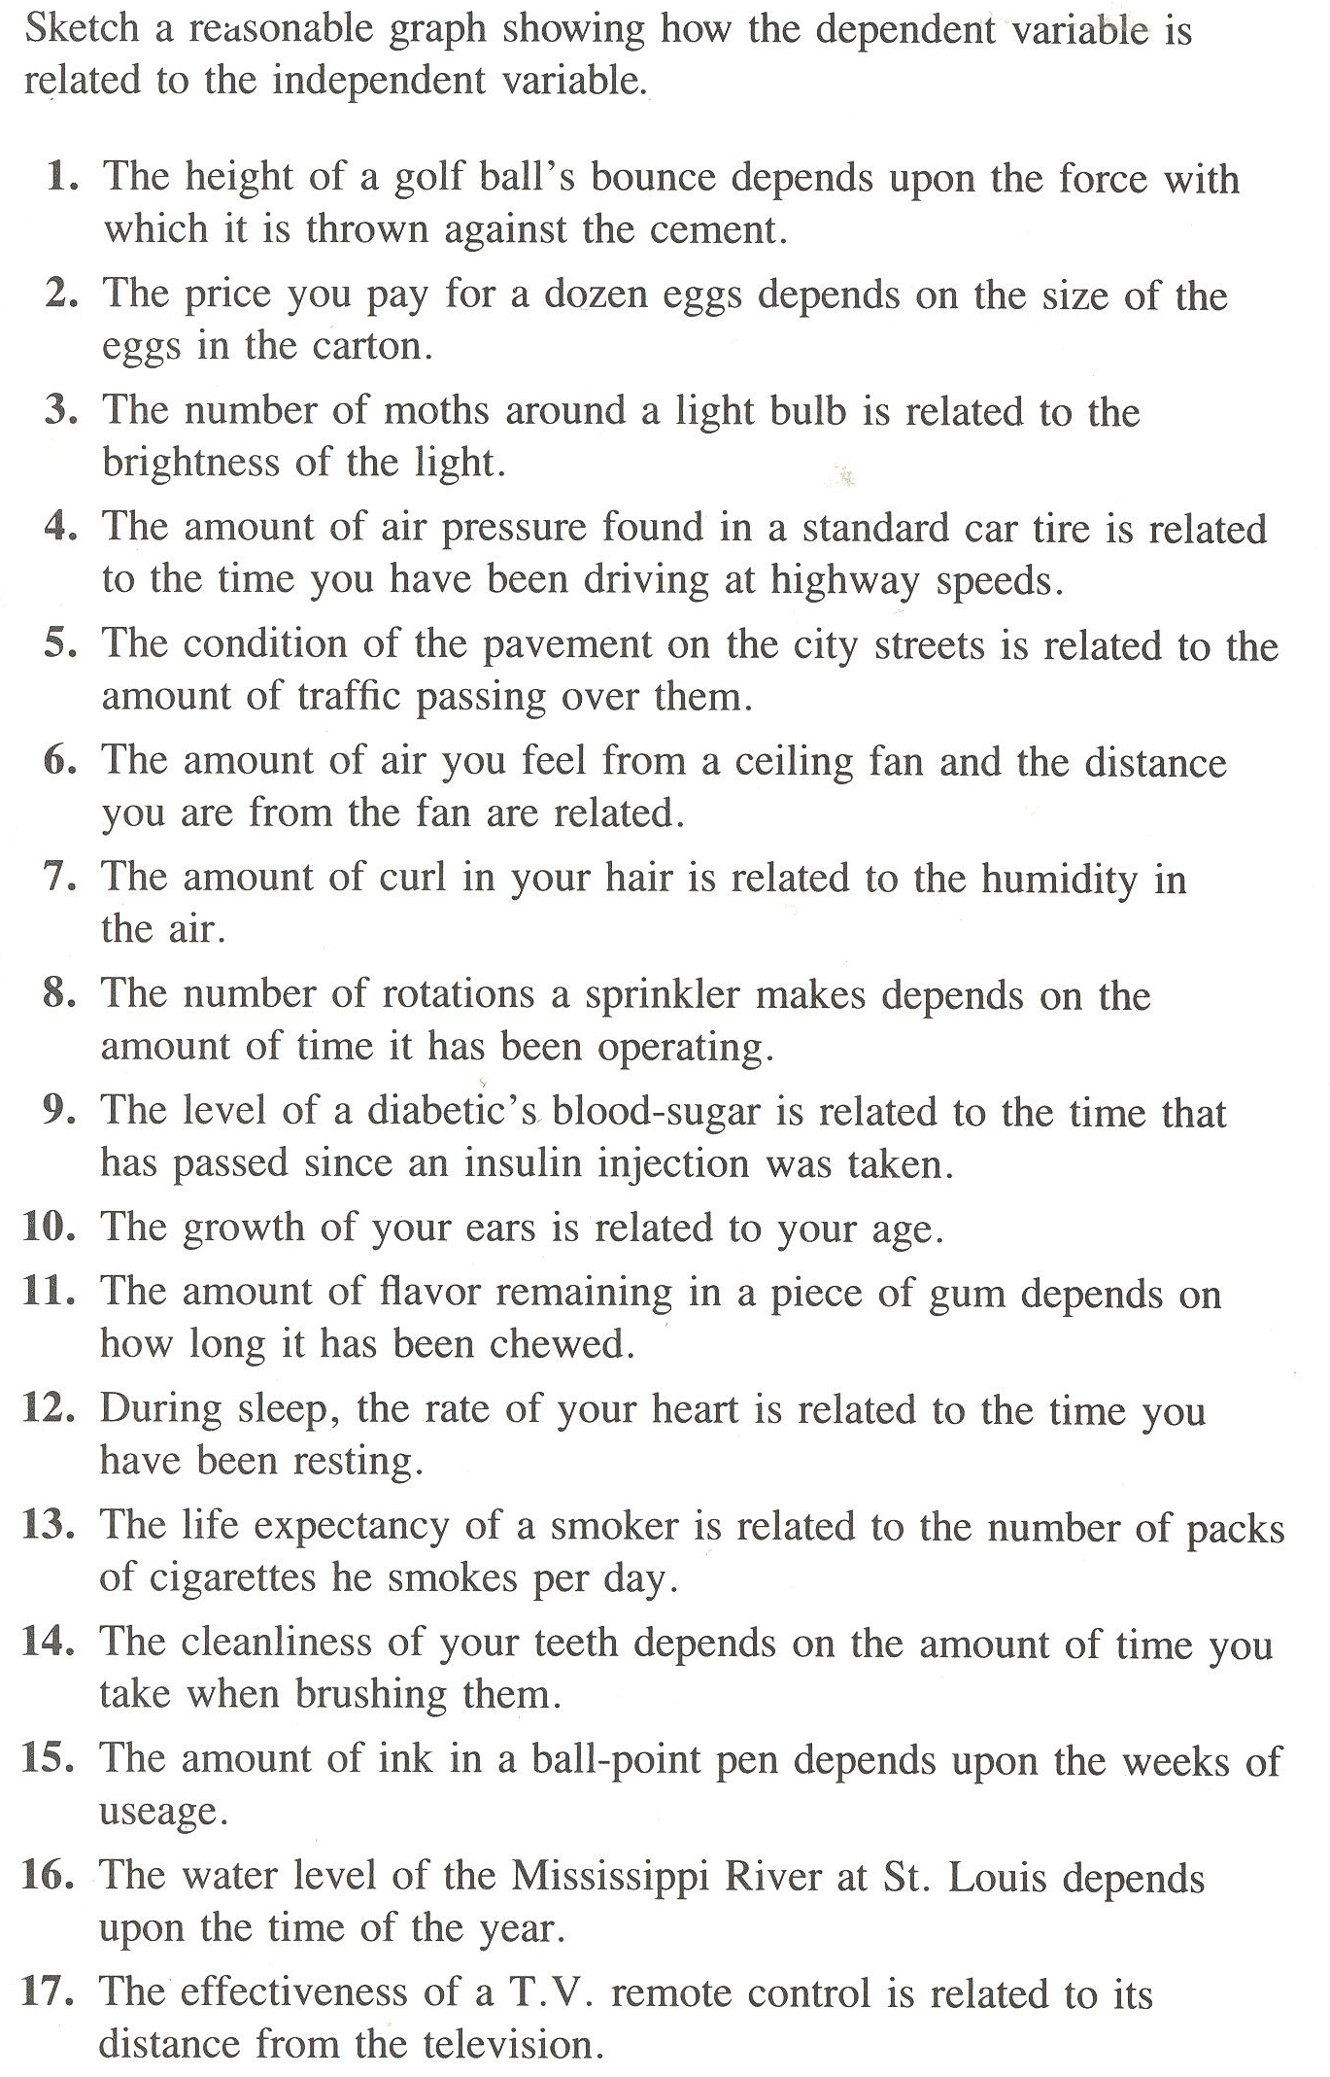

# | Independent Variable | Dependent Variable | Correlation (negative or positive slope)
1
2
3
4
5
6
7
8
9
10
11
12
13
14
15
16
17

